Rotary Club of Kathmandu Mid-Town
Breakfast Chatter




9 December 2011 The Weekly Bulletin of Rotary Club of Kathmandu Mid-Town Bc-12.9/011-12

District: 3292 Web: www.rotarymidtown.org.np Club Id : 26776

DECEMBER IS THE FAMILY MONTH
Rotarians, clubs, and districts worldwide are encouraged to demonstrate their commitment to family and community through projects, activities, and events in celebration of Family Month .

Friday, 2 December:
Dr. Donald Sammut, a plastic surgeon and specialist on hand surgery, was our guest Speaker for the day. Dr Sammut is from United Kingdom, and has been in India and Nepal providing his expertise service on hand surgery. He has reconstructed hands of many leprosy patients in a project initiated by Baba Amte at Nagpur in India. He was pleased to see many leprosy patients working in various fields for their livelihood after reconstruction and find that their social acceptability enhanced. In Nepal, he has operated leprosy patients at Anand Ban Hospital in Lele and has trained the hospital doctors Dr. Indra Sthapit and Dr. Sapkota. He shared his experiences on “Hand Surgery in India and Nepal” during his presentation.

Weekly Meetings and Programs :
Date | Program/Speaker | Program/Topics of Presentation
9 December 2011 | DG Visit | District Governor visiting the Club
16 December 2011 | ?
23 December 2011 | Thailand's Ambassador Maris Sangiampongsa | Lessons from Thailand's Rapid Socio-economic Development
30 December 2011 | Steve Dawa Sherpa

9 December, Friday:
DG Visit
The regular Breakfast Meeting will be first conducted by DG, in which all the Committee Chairs will present progress review of activities/projects of their respective Committees. The second part will be conducted by Club President as usual.

New Planets
Astronomers have found 18 new alien planets, all of them Jupiter-size gas giants that circle stars bigger than our sun, a new study reports. The haul comes just a few months after a different team of researchers announced the discovery of 50 newfound alien worlds including one rocky planet that could be a good candidate for life. The list of known alien planets is now well over 700 and climbing fast.
Source: The Rising Nepal

Khaja program at Moti Binayak School, Dholahiti
A khaja program was organized at Shree Moti Binayak Nimna Madhyamik Vidyalaya, Dholahiti, Lalitpur for providing afternoon khaja to students on Thursday, 1st December 2011. Over 100 students were provided khir, a delicious rice boiled in milk with dry-fruits, dough-nut etc. The program was coordinated by PP Dr Lekha Tuladhar and School Principal Luxmi Karki. Rotaract President Samir and his team helped in khaja distribution. And the program was sponsored by PP RR Shrestha.

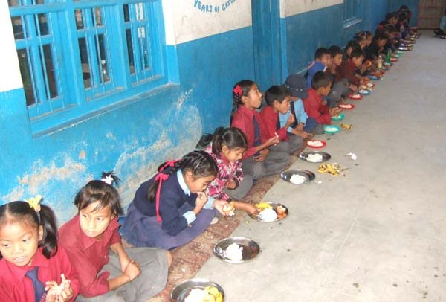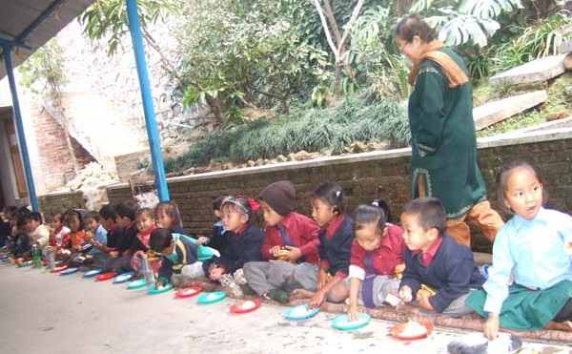
Students enjoying afternoon khaja
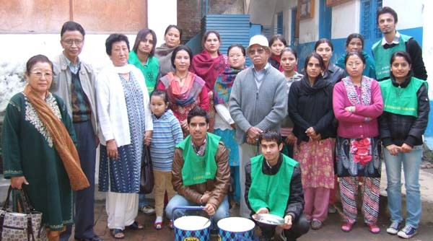
A group photo with the School management team after the khaja program was over.

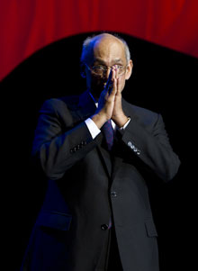
The family and the home are at the core of all our work – all our service begins here. And
through the family, we approach all of our community and indeed, all of humanity, as an
extended family, in which all members care for each other. In times of joy and in times of need,
no one is ever alone.
RI President Kalyan Banerjee

On Lighter Side : Click here ⇩


Great Quotes:
This is my simple religion. There is no need for temples; no need for complicated philosophy. Our own brain, our own heart is our temple; the philosophy is kindness;
Tenderness and kindness are not signs of weakness and despair but manifestations of strength and resolution;
Kindness is loving people more than they deserve;
The best portion of a good man's life is his little, nameless, unremembered acts of kindness and of love;
You often meet your fate on the road you take to avoid it;
Life is made up, not of great sacrifices or duties, but of little things, in which smiles, and kindnesses, and small obligations, given habitually, are what win and preserve the heart and secure comfort.

Please send project/activity information, suggestions and photos etc to :
BC Editor: RR Shrestha email: rryes@wlink.com.np

9 December 2011 The Weekly Bulletin of Rotary Club of Kathmandu Mid-Town bc-12.9/011-12

